Alway Primary School
ICT Acceptable Use Policy
for Pupils.

Agreed by Governors

Signed:

Date:
Graeme Thompson …...…….2016

These are the rules I agree to follow when using any digital technology:

- I will ask permission from a teacher before using ICT equipment and will use only my own login and password.

- To protect myself and other pupils, if I see anything I am unhappy with or receive messages I do not like, I will immediately close the page and tell a teacher or adult.

- I will not access other people's files or send pictures of anyone without their permission.

- I will not bring CDs or memory sticks into school unless I have permission and they have been checked to ensure that they are virus free.

- I will only e-mail people I know, or that my parent/teacher has approved and the messages I send will be polite and sensible.

- I will not give my home address or phone number, or arrange to meet someone I have met online.

- When I am using the internet to find information, I will check that the information is accurate as I understand that the work of others may not be truthful.

- Where work is protected by copyright, I will not try to download copies (including music and videos).

- I will not use my mobile phone in school for any reason unless arranged by a staff member and parent.

- I understand that the school may check my computer files and may monitor the Internet sites I visit.

- If I am involved in incidents of inappropriate behaviour that involve members of the school community (e.g. cyber-bullying, using images/information without permission), the school will take action according the Behaviour Policy.

- I understand that if I do not follow these rules I may not be allowed to use ICT in school and my parents/carers may be contacted.

- I will follow the rules of Zip it, Block it, Flag it to keep me safe online.
This Acceptable Use Policy is intended to ensure:

- That young people will be responsible users and stay safe while using the internet and other digital technologies for educational, personal and recreational use.

- That school systems and users are protected from accidental or deliberate misuse that could put the security of the systems and users at risk.

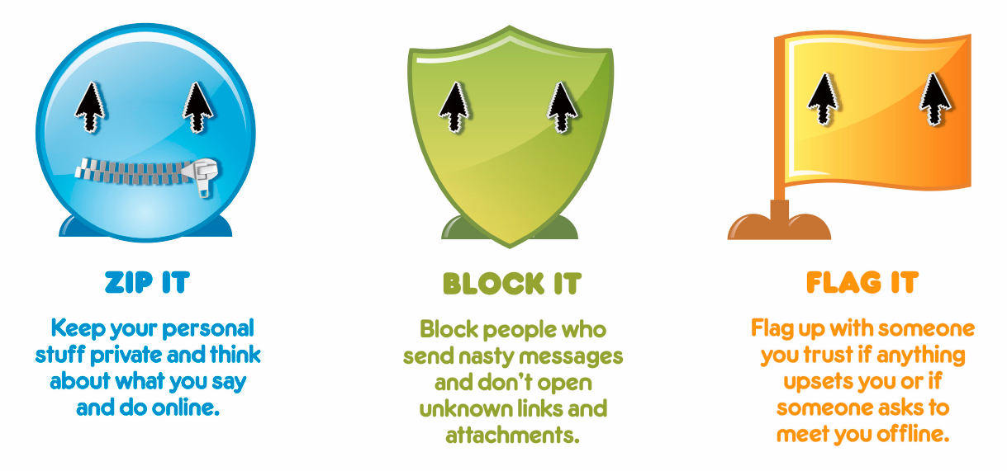

Name of pupil

Class

Signed by parent/carer

Date

Use of Digital / Video Images
The use of digital / video images plays an important part in learning activities. Students / Pupils and members of staff may use digital cameras to record evidence of activities in lessons and out of school. These images may then be used in presentations in subsequent lessons.
Images may also be used to celebrate success through their publication in newsletters, on the school website and occasionally in the public media. The school will comply with the Data Protection Act and request parents / carers permission before taking images of members of the school. We will also ensure that when images are published that the young people cannot be identified by the use of their names.
In accordance with guidance from the Information Commissioner’s Office, parents / carers are welcome to take videos and digital images of their children at school events for their own personal use (as such use in not covered by the Data Protection Act). To respect everyone’s privacy and in some cases protection, these images should not be published / made publicly available on social networking sites, nor should parents / carers comment on any activities involving other students / pupils in the digital / video images.
Parents / carers are requested to sign the permission form below if they DO NOT wish to allow the school to take and use images of their children.
------------------------------------------------------------------------------------------------

Digital / Video Images Permission Form
Parent / Carer’s Name:
Pupil Name: Class:
As the parent / carer of the above pupil, I do not agree to the school taking and using digital / video images of my child / children.
Signed: Date:

